CONFIGURATION SCREENSHOT OF MICROSOFT OUTLOOK WITH AMAZON SES

- Tools > account setting > new account page screenshot

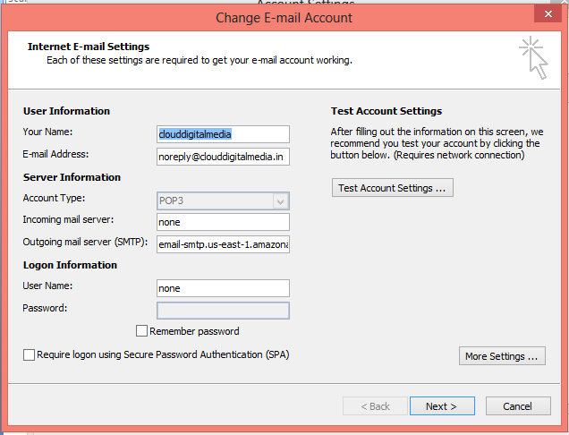

- Click on more setting in first step. You will find below screen.

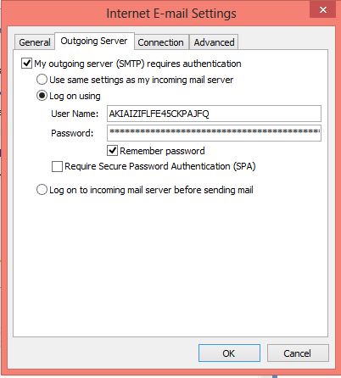

- Click on advanced tab in the same dialog box which looks like below.
